The fungus known as ceratocystis fagacearum causes a disease called oak wilt, and has recently been spotted in Long Island. Oak wilt kills thousands of oaks each year across Midwestern and Atlantic states and has been spreading through western and central Pennsylvania for years may now be spreading to New Jersey.
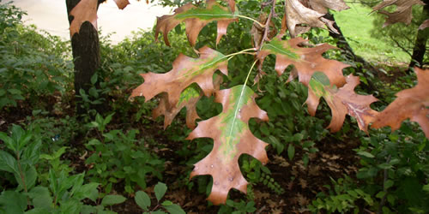
The fungus clogs the vessels that carry fluids up through the tree so it cannot circulate water and nutrients to its branches and leaves. There is no known treatment for oak wilt, and most infected trees die within the year. An infected tree’s leaves turn dull green or bronze, look water-soaked, wilt, and then turn yellow or brown (image above).
New Jersey residents are encouraged to buy firewood and oak saplings locally to prevent spreading the fungus. To protect oaks on your property, avoid pruning the trees during the growing season, because the open wounds created by pruning can attract beetles that might be carrying the fungus.

Special thanks tot The Land Conservancy of New Jersey for posting this article.
19 Boonton Avenue
Boonton, New Jersey 07005
http://tlc-nj.org/

