**Commission News:**

**NJ Community Forestry Program: CORE Training**

Mountain Lakes was proudly represented at the October 2015 NJ Community Forestry Core Training Program sponsored by Shade Tree Federation of NJ. Joining from the Shade Tree Commission were Sandy Batty and Chris Capodanno.

The Sessions included lectures by leaders from Rutgers Forestry Program and the NJ Department of Environmental Protection.

There was a clear outline of the **new challenges** facing us:

* Damages & Costs to the Mountain Lakes Community
* Public Safety concerns from hazardous trees
* Environmental Risks, including the Emerald Ash Borer, Asian Longhorned Beetle, Gypsy Moth, and the Oak Leaf Bacterial Scorch
* Wacky Weather will continue in NJ, and prevention is better than the cure:

• **Hurricane Sandy** • **Nor'easters**

• **Hurricane Irene** • **Micro-Bursts**

• **Halloween Snow** • **Tornados**

The Fall is an important time to reflect on the **Benefits we receive from our Mountain Lakes Tree Resource’s**, and how we can to protect these trees:

* Increase Property Values Reduce Soil Erosion
* Control Utility Costs Stormwater/Flood Management
* Cleaner Air Reduce Noise Pollution
* Aesthetics/Walking the Boulevard Wildlife Habitat

Decisions we make today will affect our children, grandchildren, and the value of the Mountain Lakes in the future

The Shade Tree Commission is working with the Council this month on the Mountain Lakes Community Forestry Management Plan. Key components include our Tree City USA designation, Continued Education Requirements and Community Enrichment, and Hazardous Tree Identification before the unforeseen weather incidents occur.

Thanks to the Mountain Lakes Community and Council support, we were one of the 32% of the NJ Municipalities with a Community Plan to protect our town and save money. The pace is clearly advancing to keep up with neighboring towns such as Summit, Glen Ridge, Madison, Mendham, and Ridgewood to name a few.

Visit the Shade Tree Commission Documents page of our website to learn more about how we can protect our trees

**Environmental Risks:**

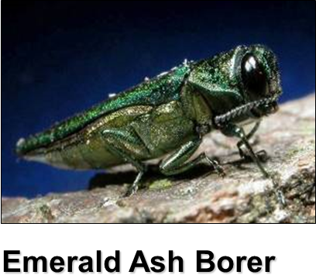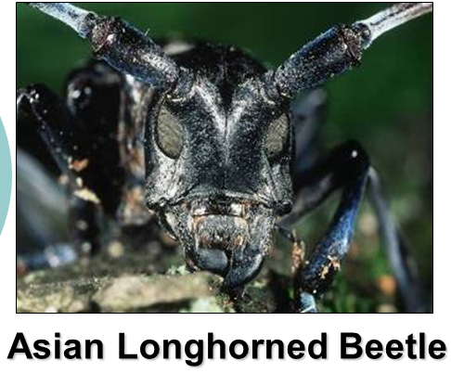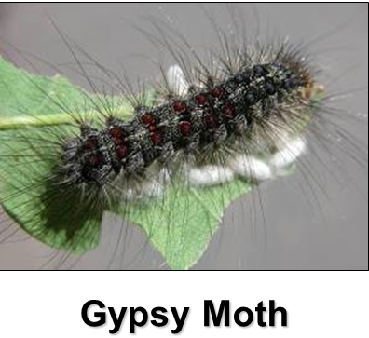

**Community and Damage Risks:**

