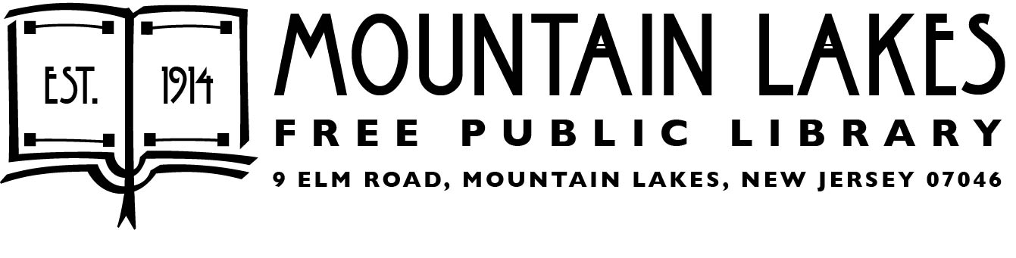

Fall Lecture Series
Sundays at 3pm
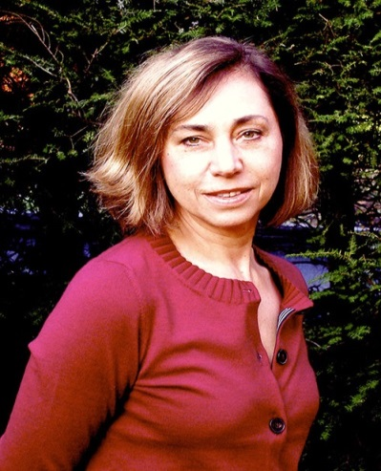

Oct 8th Coming of Age in Leningrad
during the Cold War
Ms. Elena Gorokhova, author of A Mountain of Crumbs and Russian Tattoo, will discuss growing up in Leningrad during the Cold War.

Oct 22nd Greetings from Bertrand Island
Amusement Park!

Take a trip down memory lane with Mr. Martin Kane, president of the Lake Hopatcong Historical Museum, who will discuss the history of the beloved Bertrand Island Amusement Park.

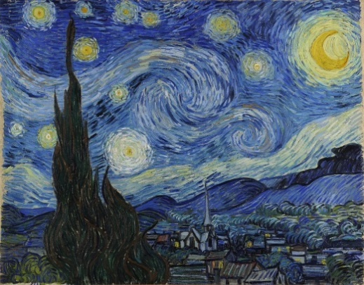
Nov 5th Van Gogh: An Armchair Tour

Painter Vincent van Gogh produced more than 2,000 works of art in his
last decade. Explore some of his masterpieces with Dr. Michael Norris, former educator at the Metropolitan Museum of Art.

Nov 19th The Music of the 1950s

Back by popular demand! Dr. Robert Butts joins us once again, this time to discuss the music that made the 1950s unforgettable.

